Milestone One: Project Proposal
Selected 2D Scene Image:
The photo I chose shows a modern wooden desk setup with a monitor, laptop, keyboard, coffee cup, camera, and headphones.
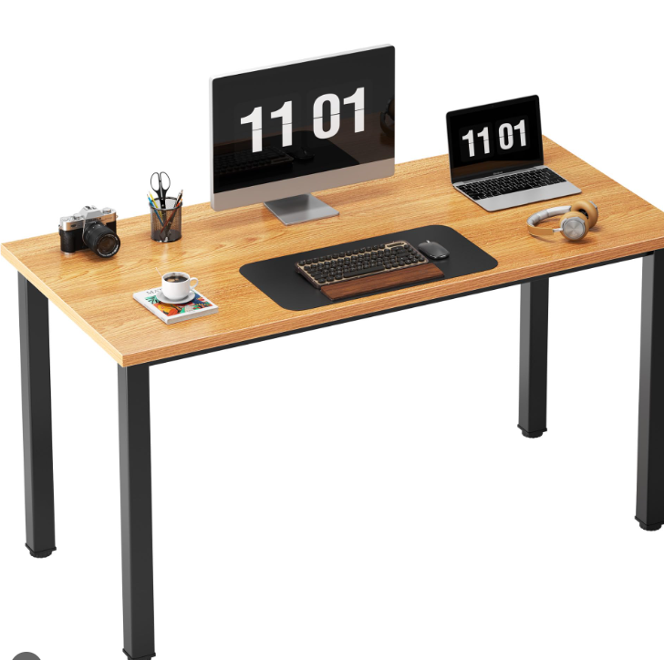 (Amazon, n.d.)
I picked this picture because it has clean, simple shapes that are easy to build in 3D. The flat desk surface and the mix of box-shaped and round objects make it a good fit for OpenGL. It also gives enough variety to show scaling, rotation, and translation without being too complex.
Objects to Replicate in 3D:
For my 3D scene, I plan to model four main objects from the photo:
Desktop Monitor – a rectangular shape that can be built from boxes.
Coffee Cup – adds some curved geometry and variety to the scene.
Camera – a mix of box and cylinder shapes to show a more detailed object.
Desk Surface – the main plane that all other objects sit on.
These objects give me a good mix of basic shapes and will help me practice different transformations in OpenGL.
3D Shapes and Construction Plan:
Object | Basic 3D Shapes | How It Will Be Built
Desk | Plane and four cylinders or boxes for the legs | A large plane for the top surface and scaled legs for support.
Monitor | Boxes and a thin cylinder | Boxes for the screen and base, and a small cylinder for the pivot.
Coffee Cup | Cylinder and torus | The cylinder forms the body, and the torus creates the handle.
Camera | Box and cylinder | A box for the body and a cylinder for the lens.
Each object will be placed on the desk and adjusted in size and position to match the photo. The camera view will be angled slightly above the desk to show depth and spacing between the items.
Scope and Feasibility:
This project can be completed using the OpenGL shapes and tools already available in the course content zip file. I’ll start with the desk and then build each object one at a time. Once the shapes are placed, I can adjust the scale and position, so the layout looks close to the original photo. Later milestones will add textures, color, and lighting to make it more realistic.

Reference:
Amazon. (n.d.). Need Computer Desk 55-inch, Large Office Desk with Metal Frame [Product image]. Amazon. https://www.amazon.com/Need-Computer-Certification-Training-AC3BB-120/dp/B01DB5BWOI

